

**Figure Series**

**Directions (1-25):** In each of the questions given below which one of the five answer figures on the right should come after the problem figures on the left, if the sequence were continued?

1. C:\Users\tsuser.PC\Desktop\final.png

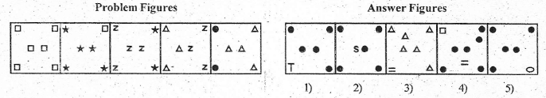

1. C:\Users\tsuser.PC\Desktop\final.png

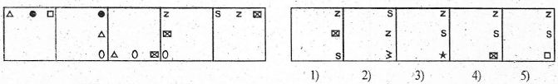

1. C:\Users\tsuser.PC\Desktop\final.png

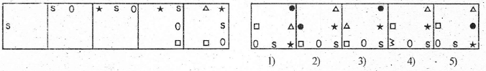

1. C:\Users\tsuser.PC\Desktop\final.png

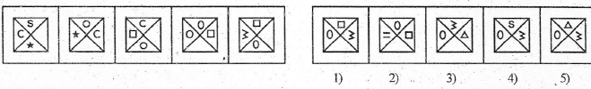

1. C:\Users\tsuser.PC\Desktop\final.png

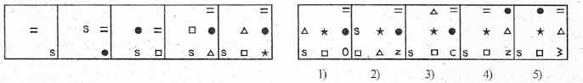

1. C:\Users\tsuser.PC\Desktop\final.png

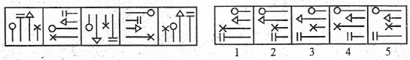

1. C:\Users\tsuser.PC\Desktop\final.png

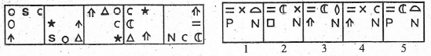

1. C:\Users\tsuser.PC\Desktop\final.png

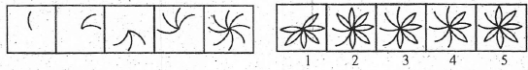

1. C:\Users\tsuser.PC\Desktop\final.png

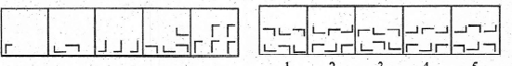

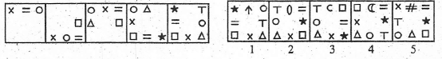

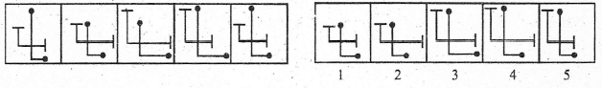

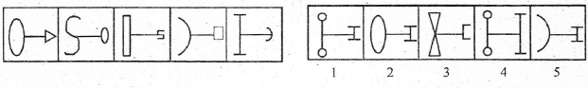

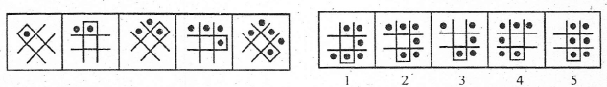

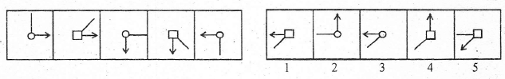

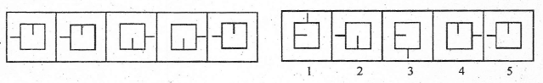

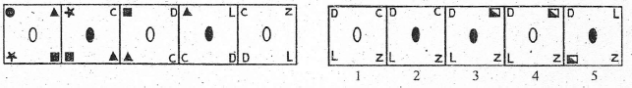

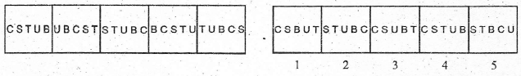

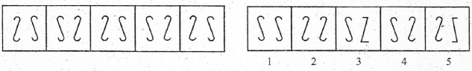

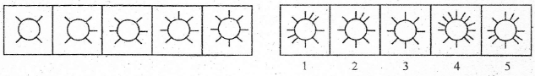

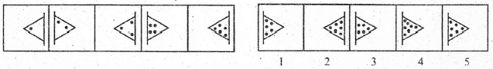

**Directions (21-25):** The second figure in the first unit of the problem figures bears a certain relationship to the first figure. Similarly one of the figures in the answer figures bears the same relationship to the first figure in the second unit of the problem figures. You are therefore to locate the figure which would fit in the question mark.

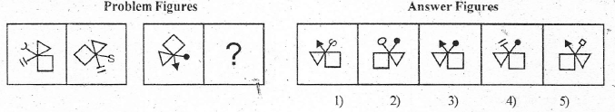

1. C:\Users\tsuser.PC\Desktop\final.png

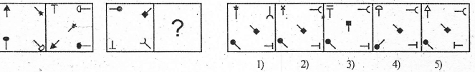

1. C:\Users\tsuser.PC\Desktop\final.png

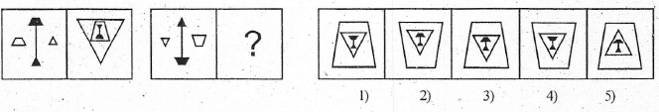

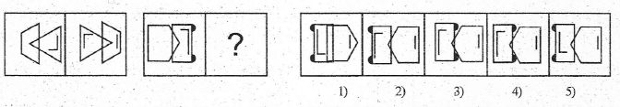

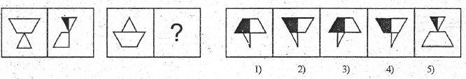

**Directions (26-30):** Each of the following series consists of seven figures, two of which at the ends are unnumbered. One of the five numbered figures does not fit into the series. Find out the figure.

C:\Users\tsuser.PC\Desktop\final.png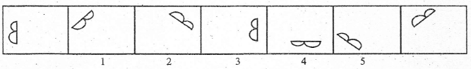

1. C:\Users\tsuser.PC\Desktop\final.png

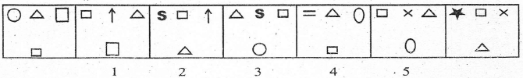

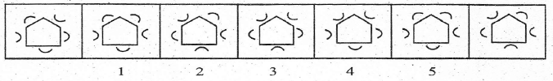

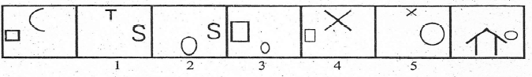

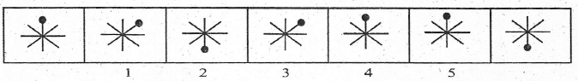

**Answers**

|  |  |  |  |  |  |  |  |  |  |
| --- | --- | --- | --- | --- | --- | --- | --- | --- | --- |
| 1 - 1 | 2 - 3 | 3 - 2 | 4 - 5 | 5 - 4 | 6 - 4 | 7 - 5 | 8 - 3 | 9 - 3 | 10 - 2 |
| 11 - 2 | 12 - 1 | 13 - 5 | 14 - 1 | 15 - 5 | 16 - 3 | 17 - 4 | 18 - 4 | 19 - 2 | 20 - 5 |
| 21 - 4 | 22 - 2 | 23 - 3 | 24 - 5 | 25 - 1 | 26 - 3 | 27 - 3 | 28 - 4 | 29 - 1 | 30 - 5 |